US Year 10 CIE – Pre-test
19 Questions | 60 minutes | Calculator allowed
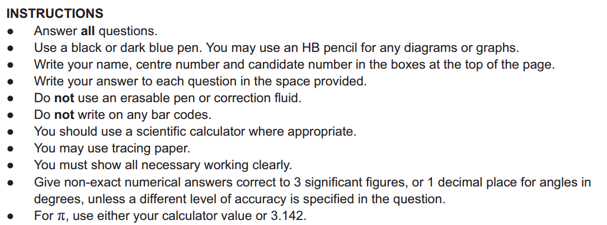

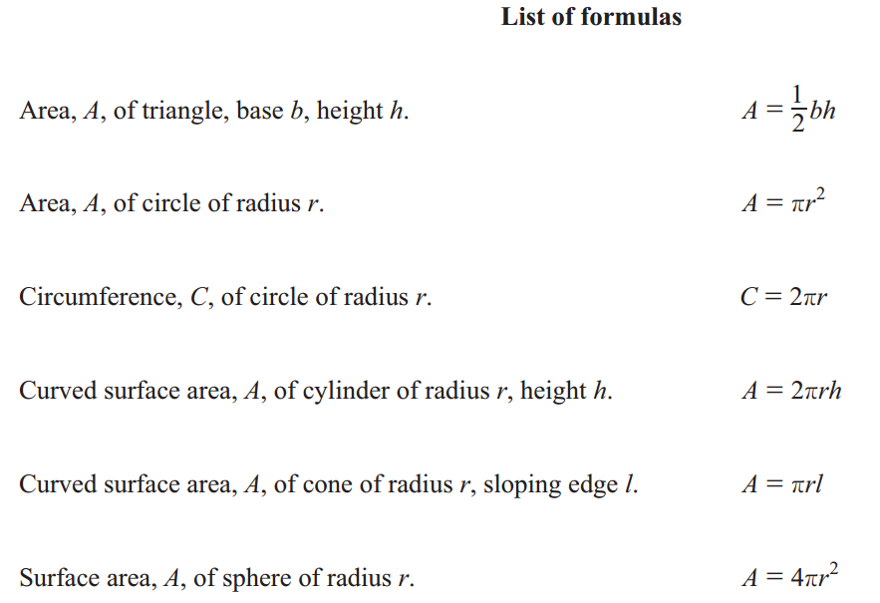
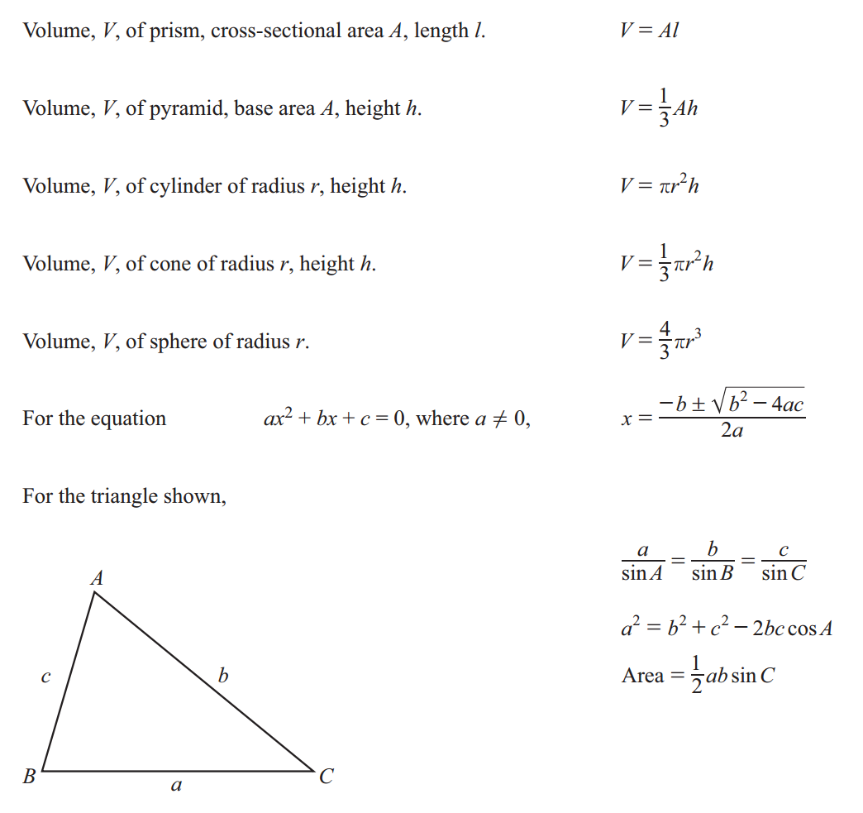

1. The diagram shows a square-based pyramid.
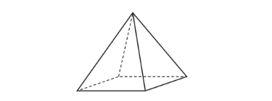
Complete this statement.
The pyramid has ____________________ edges and ____________________ vertices.

2. Convert 3 m into mm.

______________________mm

3. Apples cost $1.20 per kilogram and one banana costs 35 cents.
- Work out the total cost, in dollars, of 3 kg of apples and 7 bananas.

$_________________________
- Work out the change from $20.

$_________________________

4. Calculate 57% of 45.

_________________________

5. A train leaves station A at 13 44.
The train arrives at station B after 3 hours and 30 minutes.
- Work out the time the train arrives at station B.

_________________________
- The distance between station A and station B is 210 km.
Calculate the average speed of the train in km/h.

_________________________km/h

6. The exchange rate is $1 = 0.923 euros.
Calculate the difference between 750 euros and $846.

Give your answer in euros correct to 2 decimal places.

_________________________euros
7. Flo has a bag of counters.
She picks a counter at random from the bag.
The probability that she picks a green counter is 0.52 .
- Work out the probability that she does not pick a green counter.

_________________________

- The bag contains three colours of counters, green, pink and red.
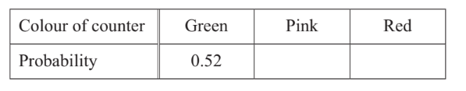
There are three times as many pink counters as red counters.
Complete the table.

- Flo picks one counter from the bag at random,
records the colour and replaces it in the bag.
She does this 200 times.
Calculate the expected number of times she picks a green counter.

_________________________

8.
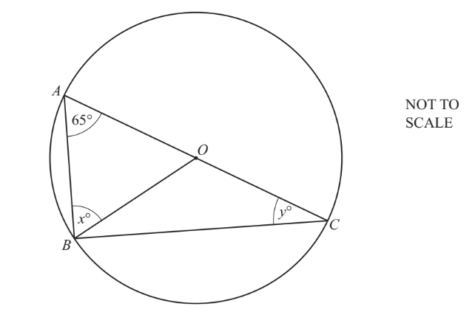
A, B and C are points on a circle, centre O, diameter AC.
Complete these statements, giving geometrical reasons.
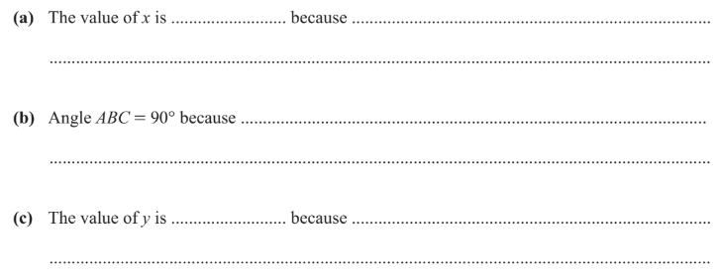

9. 2, $e$, $f,$ 20, …

A linear sequence has a first term of 2 and a fourth term of 20.
The term-to-term rule for this sequence is add k.
Work out the values of $e, f$ and $k$.

Hence, find the $n$th term.

_________________________

10. Make $T$ the subject of the formula $W=kT+y$

$T=$_________________________________

11. The equation of a line is $y=-5x+7$
Write down the gradient of this line.

_________________________
Find the coordinates of the point where this line crosses the y-axis.

(____________ , ___________)

12. Rick invests $6000 for 5 years at a rate of 9% per year compound interest.
Calculate the total interest earned during the 5 years.

$_________________________
13. A factory produces brass at a rate of 172 kilograms per hour
Convert this rate into grams per second.

_________________________ $g/s$

14. Calculate $3×10^{4}×5×10^{6}$.
Give your answer in standard form.

_________________________________

15. Solve
- $x+3=3$

$x=$_________________________

- $\frac{5y}{3}$$=8$

$y=$_________________________
16. Simplify.
- $({w^{3})}^{10}$

_________________________

- $t^{6}v^{7}×t^{3}v^{-2}$

_________________________

17. In this question, all lengths are in centimetres.
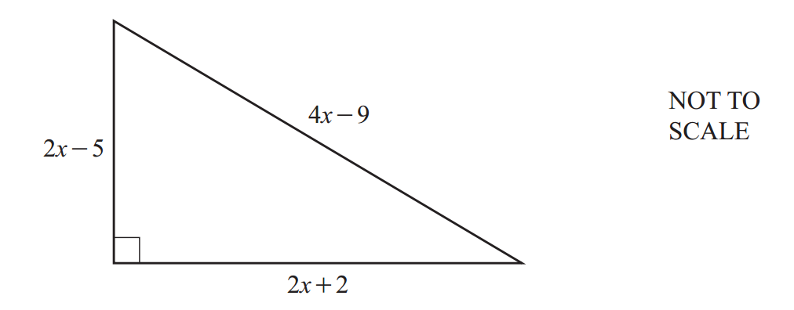
The diagram shows a right-angled triangle.

The perimeter of the triangle is 40cm.
Work out the value of x.

$x=$_________________________
18. A sphere has radius 8cm.
A cone has radius 8cm and height h.
The sphere and the cone have the same volume.
Work out the height, h, of the cone.

$h=$_________________________ cm

19. The diagram shows two right-angled triangles.
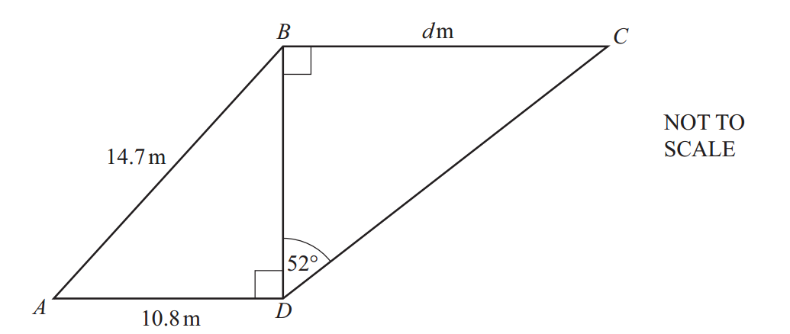

Calculate the value of d.

$d=$_________________________

